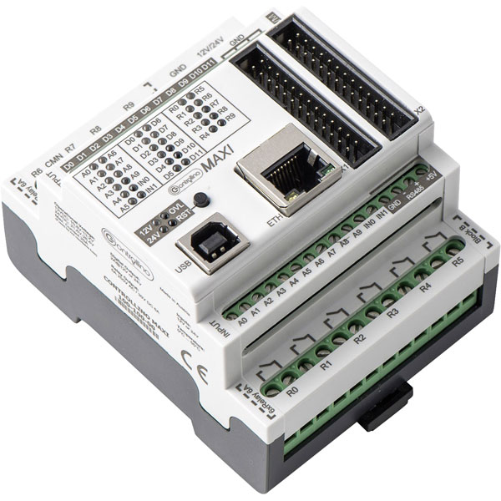

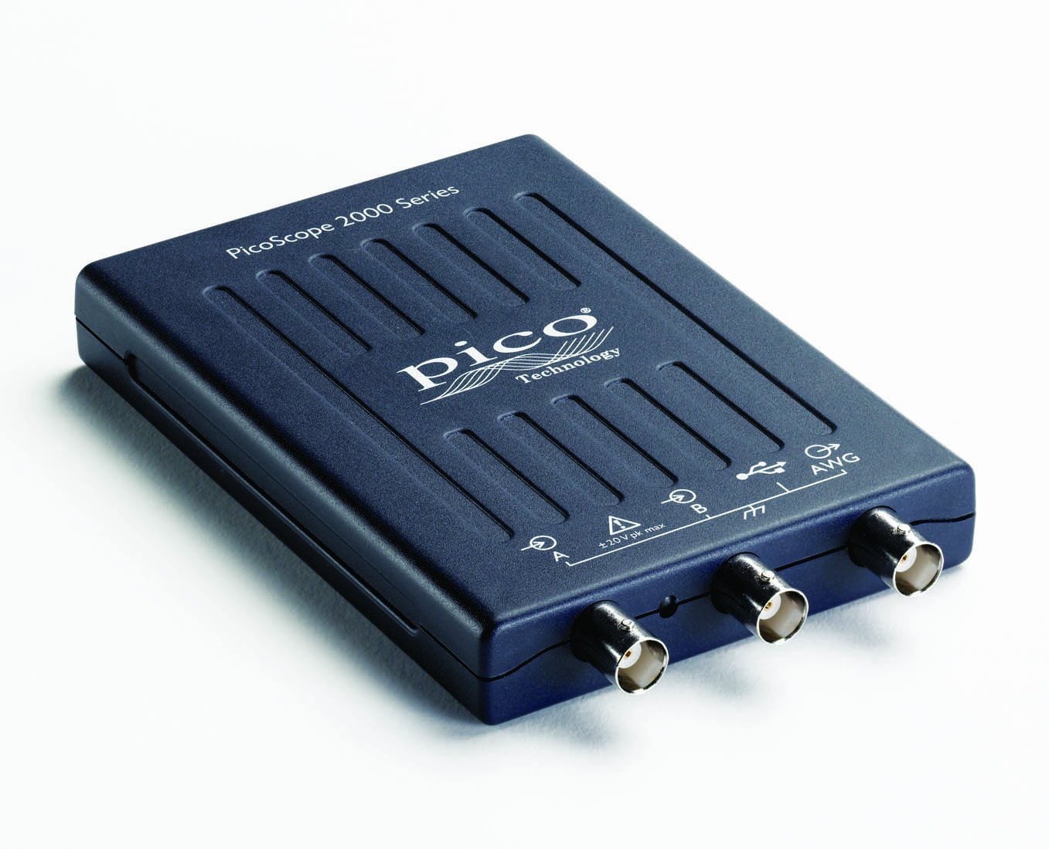

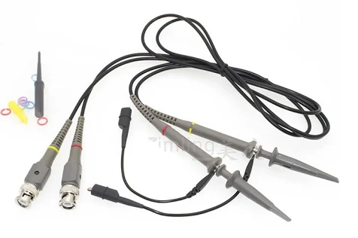

Connect the GND of the scope probe A and probe B to the Controllino GND

Connect the scope probe A to the Controllino RS485+

Connect the scope probe B to the Controllino RS485-

RS-485 Test Bench